ST.JOSEPH MATIKU SECONDARY SCHOOL
DECEMBER 2022 HOLIDAY ASSIGNMENT
AGRICULTURE FORM 2

TIME: 1 ½ HOURS

NAME………………………………….………………………... ADM NO……………..CLASS………

Attempt all questions
1. Give four importance of land preparation in crop production (4mks)
………………………………………………………………………………………………………………………………………………………………………………………………………………………………………………………………………………………………………………………………………………………………………………………………………………………………………………………………
2. List four factors that determines the type of irrigation used in crop production (4mks)
………………………………………………………………………………………………………………………………………………………………………………………………………………………………
……………………………………………………………………………………………………………………………………………………………………………………….………………………………….……
3. Give five characteristics of fertile soil (5mks)
………………………………………………………………………………………………………………………………………………………………………………………………………………………………………………………………………………………………………………………………………………
………………………………………………………………………………………………………………………………………………………………………………………………..………………………………
4. Mention five importance of drainage as a land reclamation method (5mks)
………………………………………………………………………………………………………………………………………………………………………………………………………………………………
…………………………………………………………………………………………………………………………………………………………………………………………….…………..…………………………………………………………………………..……………………
5. List four types of livestock farming practices (4mks)
………………………………………………………………………………………………………………………………………………………………………………………………………………………………………………………………………………………………………………………..……………………
………………………………………………………………………………………………………………

6. List the three types of a spanner and give two maintenance practices. (5mks)
………………………………………………………………………………………………………………
………………………………………………………………………………………………………………………………………………………………………………………………………………………………………………………………………………………………………………………………………………
7.a. Define the term minimum tillage. (1mks)
………………………………………………………………………………………………………………………………………………………………………………………………………………………………
7.b. Give five minimum tillage practices. (5mks)
…………………………………………………………………………………………………………………………………………………………………………………………………………………………………………..……………………….…………………………………………………..……………………
8. List four factors that influence soil formation (4mks)
………………………………………………………………………………………………………………………………………………………………………………………………………………………………
………………………………………………………………………………………………………………………………………………………………………………..…………………………..…………………
9. Give four importance of treating water (4mks)
………………………………………………………………………………………………………………………………………………………………………………………………………………………………
…………………………………………………………………………………………………………………………………………………………………………..………………………………..…………………
10. What are some of the agricultural practices that pollute water? (3mks)
………………………………………………………………………………………………………………………………………………………………………………………………………………………………
……………………………………………..…………………………………………………………………
11. Differentiate between a garden trowel and a masons trowel (2mks)
………………………………………………………………………………………………………………………………………………………………………………………………………………………………
………………………………………………………………………………………………………………
12.State two effects of HIV/AIDS on agriculture (2mks)
………………………………………………………………………………………………………………………………………………………………………………………………………..………………………
……………………………………………….………………………………………………………………
13. Give the uses and maintenance each of the following equipment

a)Wheel barrow (2mks)
………………………………………………………………………………………………………………..
……………………………………………………..…………………………………………………………
b)Spoke shave (2mks)
………………………………………………………………………………………………………………
…………………………………….…………………………………………………………………………
c)Milking churn (2mks)
………………………………………………………………………………………………………………
………………………………………………………………………………………………………………
14.State the reasons for proper care and maintenance of farm tools and equipments (4mks)
…………………………………………………………………………………………………………………………………………………………………………………………………………………..……………
……………………………………………………………………………………………………………………………………………………………………………….………………………….……………………
15.Give the 3 fields of horticultural farming and describe what they entail (3mks)
……………………………………………………………………………………………………………………………………………………………………………………………………………………………………………………………………………………………………………………………………………………..………………………………………………………………………………………………………
16. The diagram below shows some workshop tools. Study them and answer the questions that follow
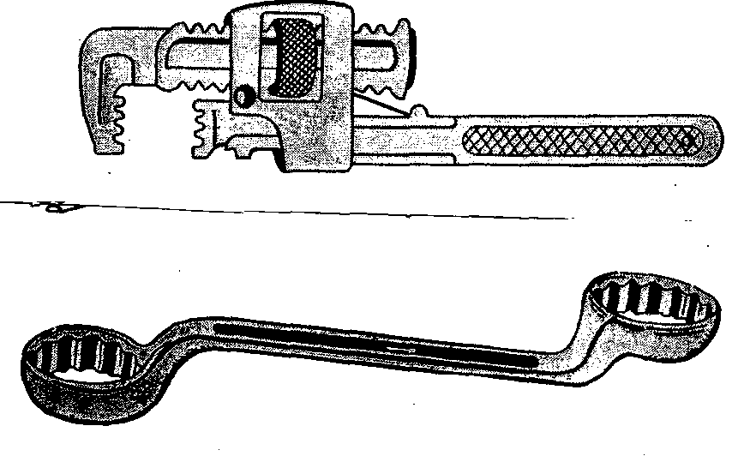

A B

(a) Identify the tools A and B (2mks)
A…………………………………………………..………………………………………
B…………………………………………………..………………………………………
(b) State the correct use of the tool labeled A (2mks)
…………………………………………………..………………………………………………
(c) Explain one maintenance practice carried out on the tool A (1mk)
…………………………………………………..…………………………………………………
17. State four categories of farm tools and equipment (4mks)
………………………………………………………………………………………………………………
………………………………………………………………………………………………………………
……………………………………………..…………………………………………………………………
……………………………………………..…………………………………………………………………

18. The diagrams labeled S and T illustrate some methods of draining waterlogged fields; use it to
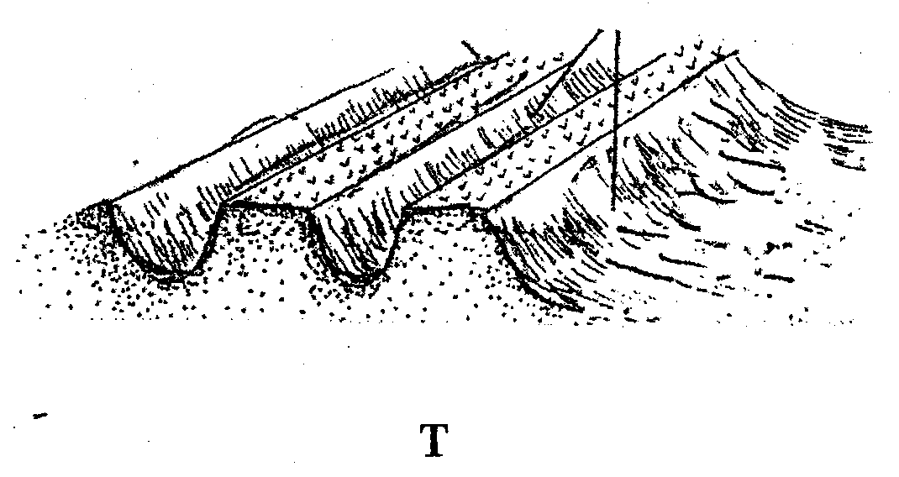
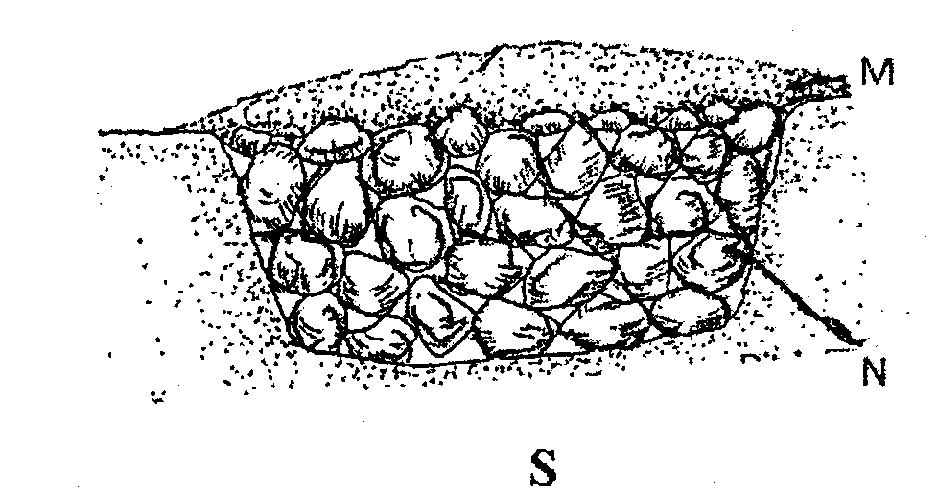
answer the questions that follow:

- Identify the methods illustrated (2mks)

S-
T-

(b) What are the materials in S labeled M and N (2mks)

(c) Name two types of crops that can be planted in the field instead of carrying out the practice
illustrated in S and T (2mks)

(d) What is the importance of carrying out irrigation (4mks)

- Distinguish between olericulture and pomology (2mks)

